**LESSON GUIDE FOR TOP CLASS WRITING**

**TERM ONE 2023**

**WEEK I ORIENTATION**

**WEEK TWO**

**LESSON (1)**

**Write the symbols**

**O l**

Lesson (2)

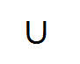

**LESSON (3)**

**Copy and write**

**OI OI OI OI OI**

**OI OI OI OI OI**

**OI OI OI OI OI**

**OI OI OI OI OI**

**Week three**

**LESSON (I)**

**Write the patterns**

**l l l l**

**Lesson (2)**

**Let us write**

**III = III= II= II=**

**II = II= II= II=**

**LESSON (3)**

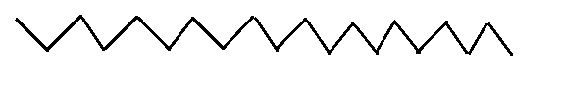**Writing is cool**



**WEEK FOUR**

LESSON (I)

Copy and write







LESSON (2)

Write and learn

**a a a a**

**a a a a**

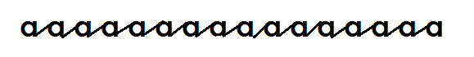

**Lesson (3)**

Write and learn

**e e e e e**

**e e e e e**



**WEEK FIVE**

Lesson (1)

Let us write and learn

**C C C C**

**C C C C**



Lesson (2)

Copy and write

**O O O O O**

**O O O O O**

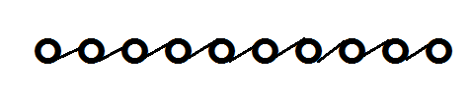

**Lesson (3)**

Write is good

K K K K K

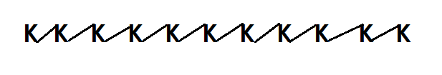K K K K K

**WEEK SIX**

Lesson (1)

I can write and learn

n n n n n

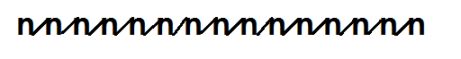n n n n n

**Lesson (2)**

Learn and write

r r r r r

r r r r r



**Lesson (3)**

Learn and write

s s s s s

s s s s s

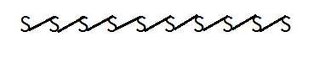

**Lesson seven**

Lesson (1)

**Let us write and learn**





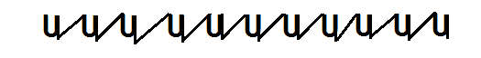

**Lesson (2)**

Writing is good

V V V V V

V V V V V

**Lesson (3)**

Write and learn

X X X X X

X X X X X

**WEEK EIGHT**

LESSON (1)

Write is fun

Z Z Z Z Z

Z Z Z Z Z



**LESSON (2)**

Writing is fun

i i i i i

i i i i i

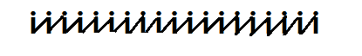

**LESSON (3)**

Write and learn

b b b b

b b b b

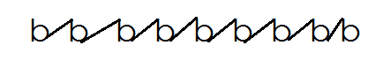

**WEEK NINE**

LESSON I

Writing is so good

d d d d

d d d d



**LESSON (2)**

Writing is learning

f f f f

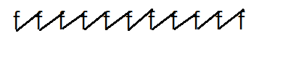f f f f

**Lesson (3)**

Write and learn

h h h h

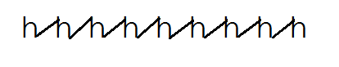h h h h